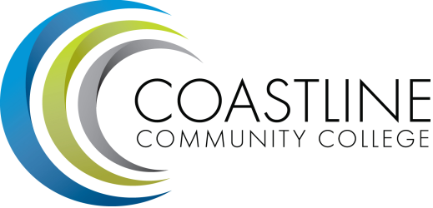
Accreditation Chairs Meeting Agenda
5/04/17
1:00 pm - 3:00 pm
College Center 4th Floor Conference Room

Committee Mandate: To guide the College through the self-evaluation process for the purpose of continuous self-improvement as evidenced by the Institutional Self-Evaluation Report.

- CALL TO ORDER
  - Roll Call
  - Welcome
  - Adoption of Agenda
  - Minutes from 4/20

- SPECIAL REPORTS & UPDATES

- ACTION ITEMS
  - File Naming Convention

- STANDING REPORTS
  - Standard I (chairs)
  - Standard II (chairs)
  - Standard III (chairs)
  - Standard IV (chairs)

- DISCUSSION ITEMS
  - Homework for May 18 (Cite and gather evidence)
  - File Naming Convention

- ANNOUNCEMENTS (1-2 minutes per)

- ADJOURNMENT

- Next meeting will occur Thursday, May 18, 1:00-3:00 pm. Meeting schedule is 1st and 3rd Thursdays at 1:00 pm for the duration of spring 2017.

